Shell script

STEP 1:

CREATING A TEXT FILE AND STORE IT AS WITH BASH EXTENSION

AND CHANGE PERMISSION(u+v) AND ./FILENAME TO EXECUTE FROM CURRENT DIRECTORY

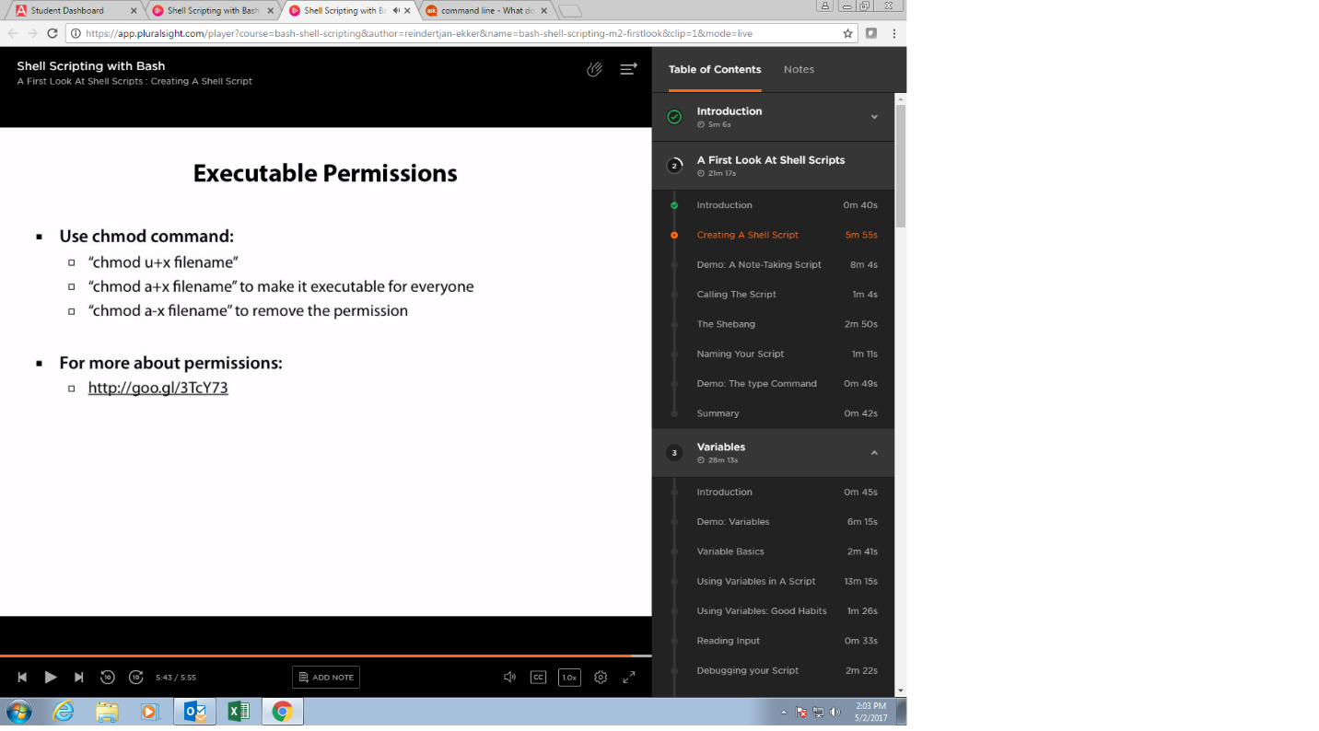

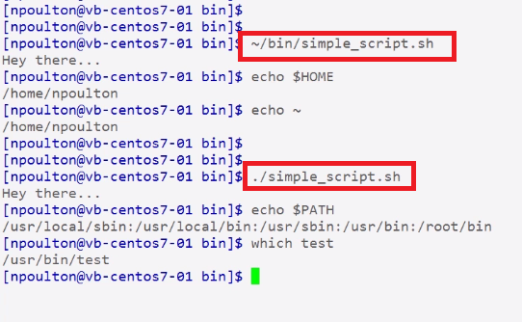

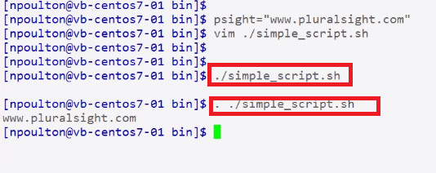

Step 2 creating a notes.txt file while will take argument 1 and store in text file

#! /bin/bash means script should be executed with bash

$1 means first argument

$* means all arguments

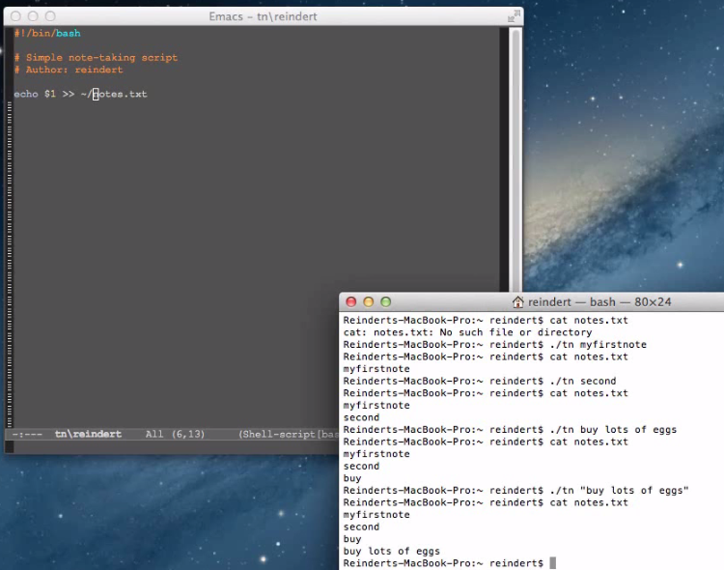

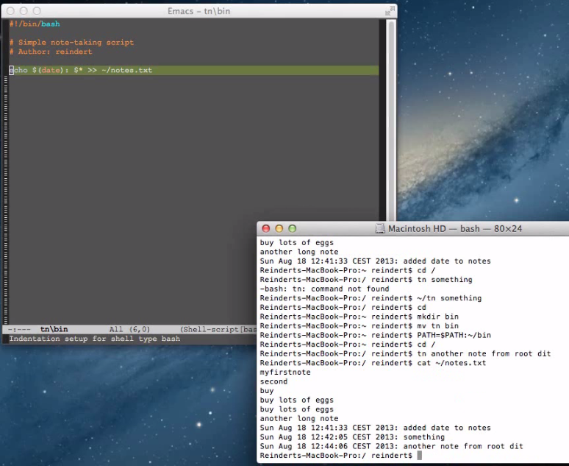

**SHE BANG**

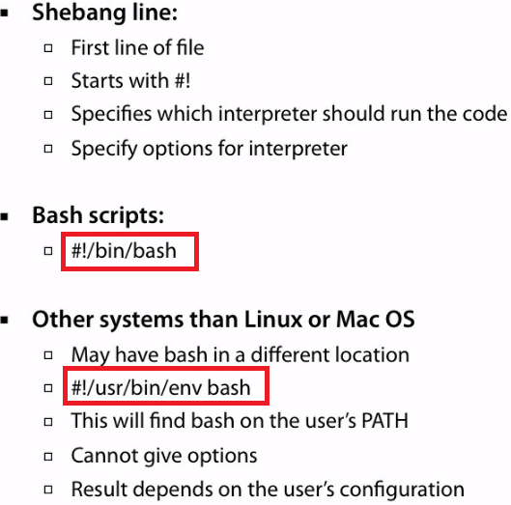

**VARIABLES**

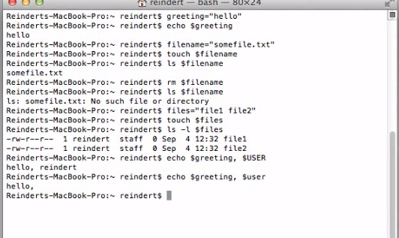

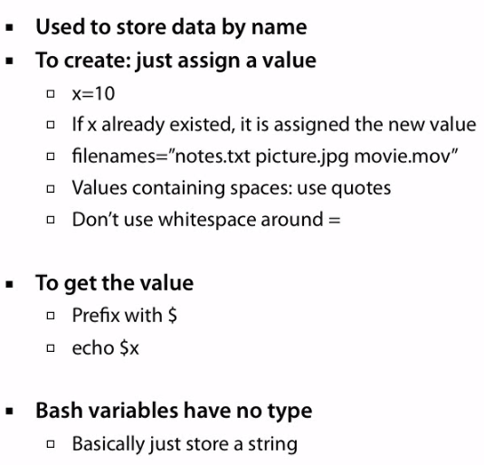

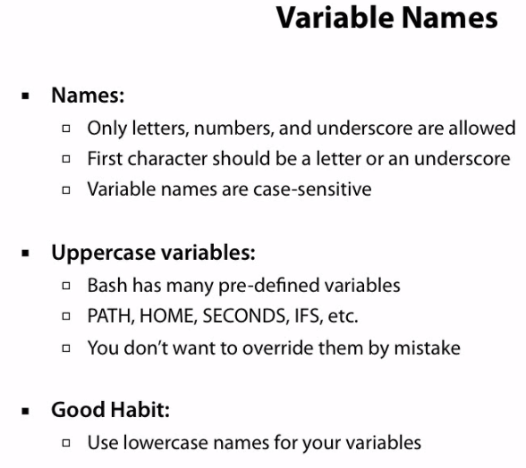

**USING VARIABLES IN SCRIPT**

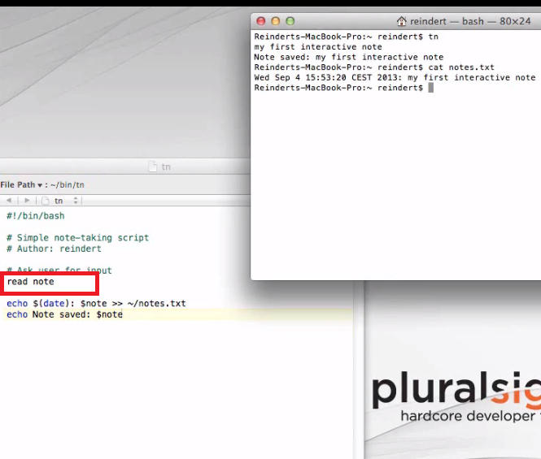

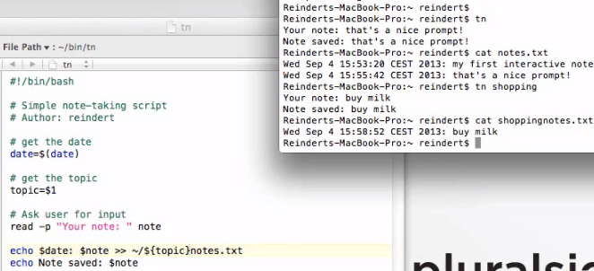

**-e is used for special characters like/n etc**

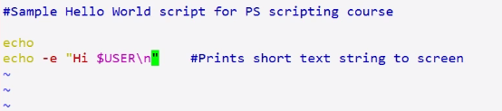

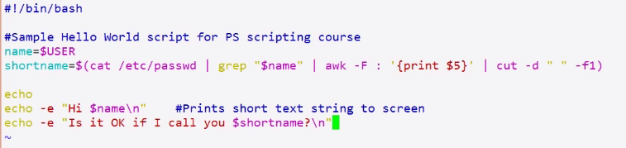

**Running second script**

**Arguments to script**

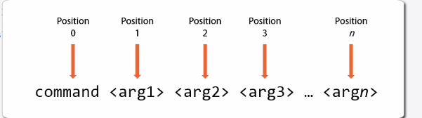

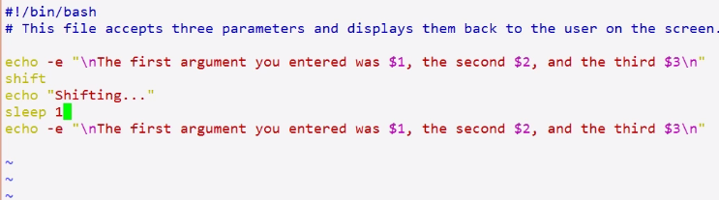

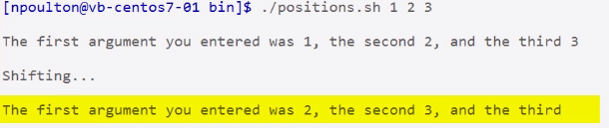

**Other arguments**

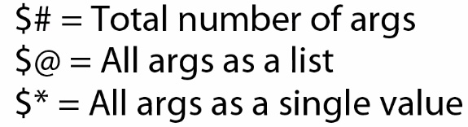

**Read command**

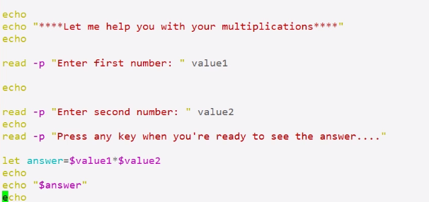

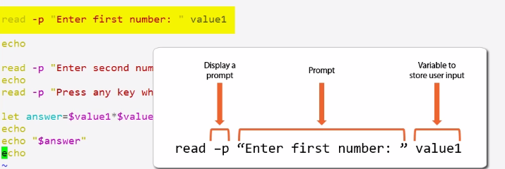

**Eventhough any key**

